A
Real-Time Research Project On

MICROWAVE MEDICAL IMAGE SEGMENTATION FOR BRAIN STROKE DIAGNOSIS
(Submitted in partial fulfillment of the requirements for the award of Degree)

BACHELOR OF TECHNOLOGY
In

COMPUTER SCIENCE AND ENGINEERING
By

V Nishitha Reddy (247R1A05J8) A Sai Rohith (247R1A05D1)
G Akshaya (257R5A0514)

Under the Guidance of

Mr. K. RANJITH REDDY
(Assistant Professor)


DEPARTMENT OF COMPUTER SCIENCE AND ENGINEERING
CMR TECHNICAL CAMPUS
UGC AUTONOMOUS
(Accredited by NAAC, NBA, Permanently Affiliated to JNTUH, Approved by AICTE, New Delhi)
Recognized Under Section 2(f) & 12(B) of the UGCAct.1956, Kandlakoya (V), Medchal Road, Hyderabad-501401.
April, 2026.

DEPARTMENT OF COMPUTER SCIENCE AND ENGINEERING


CERTIFICATE

This is to certify that the project entitled “MICROWAVE MEDICAL IMAGE SEGMENTATION FOR BRAIN STOKE DIAGNOSIS” being submitted by V. Nishitha Reddy (247R1A05J8), A. Sai Rohith (247R1A05D1) & G. Akshaya (257R5A0514) in partial fulfillment of the requirements for the award of the degree of B.Tech in Computer Science and Engineering to the Jawaharlal Nehru Technological University Hyderabad, during the year 2025-26.

The results embodied in this thesis have not been submitted to any other University or Institute for the award of any degree or diploma.

Mr. K. Ranjith Reddy Dr. Nuthanakanti Bhaskar Assistant Professor HoD
INTERNAL GUIDE

ACKNOWLEDGEMENT
We take this opportunity to express our gratitude to the people who have been instrumental in the successful completion of this project, we take this opportunity to express our profound gratitude and deep regard to our guide Mr. K. Ranjith Reddy Assistant Professor for his exemplary guidance, monitoring and constant encouragement throughout the project work. The blessing, help and guidance given by him shall carry us a long way in the journey of life on which we are about to embark.

We take this opportunity to extend our heartfelt appreciation to the Project Review Committee (PRC) Coordinators—, Mr. K. Ranjith Reddy, Mrs. M. Sunitha, Mrs. Tabeen Fatima and Mrs. M. Srilekha —for their unwavering support, insightful guidance, and valuable inputs, which played a crucial role in steering this project through its various stages.

Our sincere appreciation also goes to Dr. Nuthanakanti Bhaskar, Head, for his encouragement and continuous support in ensuring the successful completion of our project.
We are deeply grateful to Dr. A. Raji Reddy, Director, for his cooperation throughout the course of this project. Additionally, we extend our profound gratitude to Sri. Ch. Gopal Reddy, Chairman, Smt. C. Vasantha Latha, Secretary and Sri. C. Abhinav Reddy, Vice-Chairman, for fostering an excellent infrastructure and a conducive learning environment that greatly contributed to our progress.

We also acknowledge and appreciate the guidance and assistance provided by the faculty and staff of CMR Technical Campus, whose contributions have been invaluable in bringing this project to fruition.
Lastly, we sincerely thank our families for their unwavering support and encouragement. We also extend our gratitude to the teaching and non-teaching staff of CMR Technical Campus for their guidance and assistance. Their contributions, along with the support of everyone who helped directly or indirectly, have been invaluable in the successful completion of this project.

V Nishitha Reddy (247R1A05J8)
A Sai Rohith (247R1A05D1)
G Akshaya (257R5A0514)

VISION AND MISSION

INSTITUTE VISION:
To Impart quality education in serene atmosphere thus strive for excellence in Technology and Research.

INSTITUTE MISSION:
- To create state of art facilities for effective Teaching- Learning Process.

- Pursue and Disseminate Knowledge based research to meet the needs of Industry & Society.

- Infuse Professional, Ethical and Societal values among Learning Community.

DEPARTMENT VISION:
To provide quality education and a conducive learning environment in computer engineering that foster critical thinking, creativity, and practical problem-solving skills.

DEPARTMENT MISSION:
- To educate the students in fundamental principles of computing and induce the skills needed to solve practical problems.

- To provide State-of-the-art computing laboratory facilities to promote
industry institute interaction to enhance student’s practical knowledge.

- To inculcate self-learning abilities, team spirit, and professional ethics among the students to serve society.

ABSTRACT

Stroke is a life-threatening neurological disorder and one of the leading causes of mortality and long-term disability worldwide. Rapid identification and differentiation between ischemic and hemorrhagic stroke are critical, as treatment strategies vary significantly and delays can result in irreversible brain damage. Conventional neuroimaging modalities such as computed tomography (CT) and magnetic resonance imaging (MRI) provide high diagnostic accuracy; however, they are costly, time-consuming, immobile, and often inaccessible in rural or emergency pre-hospital environments. To address these limitations, this project presents a comprehensive framework for Microwave Medical Image Segmentation for Brain Stroke Diagnosis, focusing on safe, portable, low-cost, and real-time stroke detection. Microwave imaging is an emerging biomedical technique that employs low-power, non-ionizing electromagnetic waves to probe biological tissues. The underlying principle is based on the contrast in dielectric properties—specifically permittivity and conductivity—between healthy brain tissues and stroke-affected regions. Hemorrhagic strokes, characterized by intracranial bleeding, and ischemic strokes, caused by vascular blockage, exhibit distinct dielectric signatures. By transmitting microwave signals through a multi-antenna array surrounding the head and analyzing the scattered field data, it is possible to reconstruct images that highlight abnormal tissue regions. The proposed system consists of four major components: data acquisition, signal processing and image reconstruction, image preprocessing, and segmentation with classification. In the data acquisition phase, a compact antenna array system captures microwave scattering parameters. Advanced signal processing techniques, including filtering and inverse scattering algorithms, are applied to reconstruct two-dimensional or three-dimensional brain images. To enhance image quality, preprocessing steps such as noise reduction, contrast enhancement, normalization, and artifact removal are performed. For accurate identification of stroke-affected regions, robust image segmentation techniques are implemented. Traditional segmentation approaches such as thresholding, region growing, edge detection, and clustering (e.g., K-means and Fuzzy C-means) are evaluated. In addition, advanced deep learning models such as Convolutional Neural Networks (CNNs) and U-Net architectures are incorporated to improve segmentation precision and automation. These models are trained to distinguish between normal tissue, ischemic regions, and hemorrhagic regions based on dielectric contrast patterns. Post-processing techniques further refine the segmented output to minimize false detections. System performance is evaluated using quantitative metrics including accuracy, sensitivity, specificity, precision, recall, and Dice Similarity Coefficient (DSC). Comparative analysis demonstrates the effectiveness of intelligent segmentation methods in improving diagnostic reliability.

LIST OF FIGURES

FIGURE NO FIGURE NAME PAGE NO
3.1 | Project Architecture of a Microwave Medical Image Segmentation for Brain Stroke Diagnosis | 14
3.2 | DataFlow Daigram Of A Microwave Medical Image Segmentation for Brain Stroke Diagnosis | 18
4.1 | Dataset directory structure with folders having all the training examples. | 24
4.2 | Screenshot of the "Tumored Brain " Folder Showing Sample Image Files | 24
4.3 | Screenshot of the Folder Showing Healthy Brain image | 25
5.1 | In above screen python server started and now open browser and enter URL as http://127.0.0.1:8000/index.html and press enter key to get below page | 33
5.2 | In above screen click on ‘New user Signup Here’ link to get below | 34
5.3 | In above screen user entering sign up details and then press button to get below page | 34
5.4 | In above screen user is login and after login will get below page | 35
5.5 | In above screen click on ‘Existing OSTU Segmentation’ link to upload microwave image and then segment using OTSU technique | 35
5.6 | In above screen click on ‘Existing OSTU Segmentation’ link to upload microwave image and then segment using OTSU technique | 36
5.7 | In above screen first image is the original image and second is the OTSU segmented image and in above image can see OTSU segmentation is not correct and now click on ‘Proposed DBIM Based Segmentation’ link to get below page | 36
5.8 | In above screen selecting and uploading ‘image’ and then click on ‘Run DBIM Algorithm’ button to get below output | 37
5.9 | output | 37
 | LIST OF TABLES
TABLE NO | TABLE NAME | PAGE NO
Table 6.2.1 | Uploading Dataset | 39
Table 6.2.2 | Classification | 39

TABLE OF CONTENTS

ABSTRACT i
LIST OF FIGURES ii
LIST OF TABLES v
- INTRODUCTION 1
  - PROJECT PURPOSE 1
  - PROJECT FEATURES 2
- LITERATURE SURVEY 4
  - REVIEW OF RELATED WORK 6
  - DEFINITION OF PROBLEM STATEMENT 9
  - EXISTING SYSTEM 9
  - PROPOSED SYSTEM 11
  - OBJECTIVES 12
  - HARDWARE & SOFTWARE REQUIREMENTS 13
    - HARDWARE REQUIREMENTS 13
    - SOFTWARE REQUIREMENTS 13
- SYSTEM ARCHITECTURE & DESIGN 14
  - PROJECT ARCHITECTURE 14
  - DESCRIPTION 15
  - DATA FLOW DIAGRAM 17
- IMPLEMENTATION 19
  - ALGORITHMS USED 19
  - SAMPLE CODE 27
- RESULTS & DISCUSSION 33
- VALIDATION 38
  - INTRODUCTION 38
  - TEST CASES 39
    - UPLOADING DATASET 39
    - CLASSIFICATION 39
- CONCLUSION & FUTURE ASPECTS 40
  - PROJECT CONCLUSION 40
  - FUTURE ASPECTS 41
- BIBILIOGRAPHY 42
  - REFERENCES 42
  - GITHUB LINK 43

INTRODUCTION

INTRODUCTION

The motivation behind the development of the microwave medical image segmentation for brain stroke diagnosis project is rooted in the critical need for advanced diagnostic tools in the field of medical imaging. Traditional methods
may lack the precision required for early detection and accurate diagnosis of
brain strokes. Microwave imaging, with its non-invasiveness and tissue penetration capabilities, presents a promising alternative. The project aims to harness the potential of microwave technology to enhance the accuracy and efficiency of brain stroke diagnosis, thereby improving patient outcomes.

PROJECT PURPOSE
The primary purpose of the Microwave Medical Image Segmentation for Brain Stroke Diagnosis project is to develop an advanced, non-invasive, and efficient diagnostic support system that improves the early detection and classification of brain strokes. Since timely identification of stroke type—ischemic or hemorrhagic—is crucial for appropriate treatment, this project aims to provide a rapid and reliable imaging solution that can assist healthcare professionals in making accurate clinical decisions

Conventional imaging techniques such as CT and MRI, although effective, may not always be readily accessible due to high costs, infrastructure requirements, and time constraints in emergency situations. Therefore, this project seeks to design a portable and cost-effective microwave-based imaging system capable of detecting abnormalities in brain tissues based on dielectric property variations.

Another key purpose of this project is to integrate advanced image segmentation algorithms with microwave imaging data to automatically identify and isolate stroke-affected regions. By incorporating intelligent processing techniques such as clustering and deep learning models, the system aims to enhance diagnostic precision, reduce human error, and support real-time analysis.

PROJECT FEATURES
The proposed system includes several innovative and functional features:
1. Microwave-Based Imaging System
- Utilizes low-power, non-ionizing electromagnetic waves
- Detects variations in dielectric properties of brain tissues
- Safe for repeated use without radiation risks
2. Non-Invasive and Portable Design
- Compact antenna array setup
- Suitable for bedside, ambulance, and remote healthcare applications
- Cost-effective compared to conventional imaging systems
3. Advanced Image Reconstruction
- Signal processing techniques for reconstructing brain images
- Noise reduction and artifact removal methods
- Enhanced image clarity for accurate analysis
4. Automated Image Segmentation
- Implementation of thresholding and clustering algorithms (K-means, Fuzzy C-means)
- Deep learning-based segmentation (CNN, U-Net models)
- Automatic identification of abnormal stroke regions

5. Stroke Classification Capability
- Differentiates between ischemic and hemorrhagic stroke
- Highlights affected tissue areas clearly
- Assists doctors in treatment planning
6. Performance Evaluation Metrics
- Accuracy
- Sensitivity and specificity
- Precision and recall
- Dice Similarity Coefficient (DSC)
7. Real-Time Processing
- Fast signal acquisition and analysis
- Immediate visualization of segmented regions
- Supports emergency clinical decision-making

LITERATURE SURVEY

2. LITERATURE SURVEY

Brain stroke diagnosis using microwave imaging and segmentation has attracted significant research interest due to the potential for non-invasive, radiation-free, and portable diagnostic systems. This literature survey explores existing work in microwave medical imaging (MWI), image reconstruction techniques, segmentation methodologies, and emerging machine learning approaches that enable stroke detection and characterization.
1. Microwave Imaging in Medical Diagnostics
Microwave imaging principles are founded on the dielectric contrast between different biological tissues when exposed to low-power electromagnetic waves. In medical applications, this contrast enables the detection of abnormalities such as tumors, hemorrhages, and ischemic regions.
- Seminal Work on Microwave Tomography: Early research by Meaney et al. explored microwave tomography for imaging soft-tissue abnormalities, illustrating how variations in permittivity and conductivity can distinguish pathological from normal tissues. They demonstrated feasibility in breast cancer imaging, laying groundwork for brain applications.
– Meaney et al. showed that the dielectric differences between healthy tissue and anomalies could be exploited using iterative reconstruction algorithms.
- Brain Imaging Application: Subsequent work extended these principles to brain applications, acknowledging the feasibility of using microwave signals to detect stroke conditions due to significant dielectric contrasts between healthy brain tissue and hemorrhagic/ischemic regions.
2. Microwave Image Reconstruction Techniques
Successful microwave brain imaging relies on advanced reconstruction algorithms that convert raw electromagnetic scattering data into interpretable images.
- Inverse Scattering Algorithms: Techniques such as Distorted Born Iterative Method (DBIM), Contrast Source Inversion (CSI), and Born Approximation have been widely used in MWI.
- – DBIM adapts the Born Approximation to iteratively update the estimated permittivity distribution, improving image quality in heterogeneous media like the human head.

Multifrequency and UWB Methods: Many researchers apply wideband frequency approaches to increase resolution and reduce noise. Multifrequency data provides more complete scattering information, enhancing reconstruction quality.
Phantom Studies and Experimental Validation: Multiple studies using head phantoms with artificial lesions have confirmed that microwave reconstruction can detect and localize stroke-like abnormalities. Antenna array configurations and lower frequency bands provide deeper penetration and better contrast for brain tissues.
3. Image Segmentation Methods in MWI
Image segmentation is the process of separating regions of interest (ROI) — specifically, stroke-affected areas — from reconstructed microwave images.
3.1 Conventional Segmentation Approaches
- Thresholding: Simple thresholding methods have been applied where pixel intensity values greater than a set threshold are classified as potential stroke regions.
– While computationally inexpensive, thresholding can be sensitive to noise and reconstruction artefacts.
- Clustering Techniques: Unsupervised clustering like K-Means and Fuzzy C-Means (FCM) has been used to segment reconstructed images based on similarity in pixel intensities.
– K-Means groups pixels into clusters representing healthy and abnormal regions.
– FCM allows pixels to belong to multiple clusters with membership probabilities, improving segmentation in noisy environments.
- Region-Based Segmentation: Region growing algorithms start from seed points and expand based on similarity criteria, allowing more contextual segmentation compared to pixel-wise techniques.
3.2 Model-Based and Hybrid Methods
- Active Contour Models: Also known as snakes, these methods evolve a boundary curve guided by image gradients to segment ROI. Active contours improve boundary detection in microwave images, especially where contrast is limited.
- Wavelet and Transform-Based Techniques: Multiresolution analysis using wavelets has been applied to highlight edges and texture features, facilitating more robust segmentation.

4. Deep Learning and Intelligent Segmentation
In recent years, deep learning has become increasingly important for medical image segmentation due to its ability to learn complex features.
- Convolutional Neural Networks (CNNs): CNN-based models have been trained to perform pixel-wise classification on reconstructed microwave images, distinguishing stroke regions from healthy tissue with higher accuracy than traditional methods.
- U-Net Architectures: U-Net and its variants — designed for biomedical image segmentation — have shown superior performance due to their encoder-decoder structure, which captures both global and local information.
- Hybrid Systems: Some studies integrate conventional preprocessing (such as filtering and normalisation) with deep learning segmentation, resulting in improved robustness against noise and artefacts inherent in microwave data.

5. Evaluation Metrics and Clinical Relevance
Across multiple studies, segmentation performance is assessed through metrics such as:
- Accuracy: Proportion of correctly classified pixels.
- Sensitivity and Specificity: Ability to correctly identify stroke regions and normal areas respectively.
- Dice Similarity Coefficient (DSC): Measures overlap between predicted segmentation and ground truth.
- Jaccard Index: Another similarity measure used in segmentation tasks.
Most experimental studies demonstrate that deep learning-based segmentation approaches outperform traditional techniques in terms of both sensitivity and specificity, suggesting strong potential for clinical use.
6. Challenges and Research Gaps
Despite progress, several challenges remain:
- Noise and Artefacts: Microwave reconstructions often contain noise due to complex tissue scattering, affecting segmentation accuracy.
- Limited Clinical Data: Majority of research relies on simulations and phantom models; large clinical datasets are still scarce.
- Real-Time Implementation: Deep learning models and reconstruction algorithms require computational efficiency improvements for real-time diagnosis.

2.1 REVIEW OF RELATED WORK

Microwave imaging (MWI) has emerged as a promising modality for non-invasive, real-time brain diagnostics due to its sensitivity to dielectric property contrasts between healthy and pathological tissues. Unlike conventional imaging like MRI or CT, microwave systems are portable, lower in cost, and do not involve ionizing radiation, making them particularly attractive for stroke diagnosis in emergency and pre-hospital settings.
Microwave Brain Imaging Systems
Early research in microwave brain imaging focused on forward and inverse problem modeling, where electromagnetic propagation through head tissues was simulated to reconstruct internal structures. Seminal contributions by Meaney et al. introduced tomographic microwave imaging systems that exploited frequency-domain scattering data to localize high-contrast regions representing hemorrhagic strokes. These works primarily relied on iterative inversion techniques such as Distorted Born Iterative Method (DBIM) and Contrast Source Inversion (CSI), which, while effective in controlled simulations, demonstrated limitations in speed and robustness when applied to real, noisy measurements.
Conventional Segmentation Approaches
Initial segmentation efforts in MWI adopted classical image processing and regularization methods. Notable works include:
- Thresholding and Region Growing: Simple threshold-based segmentation leveraging dielectric contrast to separate healthy from stroke-affected regions. Although computationally inexpensive, these approaches struggled with complex tissue boundaries and low SNR conditions.
- Level Set and Active Contour Models: Applied for boundary refinement in microwave reconstructed images. These techniques improved on thresholding by incorporating shape priors but remained sensitive to initialization and noise.
- Total Variation (TV) Regularization: Integrated into microwave inverse reconstructions to suppress artifacts and enforce edge preservation. This improved segmentation performance, particularly in differentiating ischemic areas from surrounding cerebrospinal fluid.

Machine Learning and Statistical Models
With advances in machine learning, researchers began leveraging statistical classification and feature extraction:
- Support Vector Machines (SVM) and Random Forests: Utilized to classify reconstructed dielectric maps into tissue categories. These required handcrafted features extracted from frequency-domain responses, limiting adaptability to varied stroke presentations.
- Principal Component Analysis (PCA) and Independent Component Analysis (ICA): Deployed for dimensionality reduction and noise separation prior to segmentation, helping improve classification accuracy in cluttered signal environments.

based filtering systems. These approaches used keyword-based detection and predefined heuristics to flag harmful content. While effective for textual content, these methods proved insufficient for moderating video content, as they lack the ability to analyze visual and contextual information.

Deep Learning–Driven Segmentation
The recent surge in deep learning has catalyzed significant progress in microwave medical image segmentation. Key innovations include:
- Convolutional Neural Networks (CNNs): Employed for end-to-end segmentation of microwave reconstructions. Architectures such as U-Net have been adapted to exploit spatial hierarchies inherent in dielectric maps, demonstrating superior performance over traditional methods in both synthetic and controlled experimental data.
- Autoencoders and Generative Models: Used for unsupervised feature learning, enabling better representation of stroke patterns without extensive labeled training data.
- Hybrid Models: Combine physics-based inversion with deep learning refinement modules, improving stability and interpretability. For example, learned regularizers integrated into iterative reconstruction frameworks have shown reduced artifacts and more accurate segmentation of ischemic cores.
Multi-Modal and Data Fusion Approaches
Several studies integrate microwave imaging with other modalities (e.g., ultrasound or electrical impedance tomography) to enhance segmentation reliability. Fusion techniques range from simple score-level combination to deep learning architectures that jointly optimize multi-modal feature representations. These approaches help mitigate limitations inherent in single-modality data, particularly in differentiating ischemic and hemorrhagic strokes.
Summary of Gaps and Challenges
While significant progress has been made, key challenges remain:
- Real-World Validation: Many methods achieve high performance on simulated or phantom datasets, but their robustness to in-vivo variability and noise is under-explored.
- Label Scarcity: Segmentation models often require large annotated datasets, which are difficult to obtain for microwave brain imaging.
- Computational Complexity: Advanced inversion and deep learning models can be computationally expensive, challenging for real-time clinical deployment.
- Generalizability: Models trained on specific scanner configurations may not transfer well to different hardware or patient anatomies.

DEFINITION OF PROBLEM STATEMENT
Brain stroke is a life-threatening condition that requires rapid diagnosis for effective treatment. Conventional imaging methods like CT and MRI are accurate but expensive, non-portable, and time-consuming. Microwave medical imaging offers a portable, low-cost, and safe alternative; however, the images produced often have low resolution and noise, making it challenging to accurately identify and segment stroke-affected regions. The problem, therefore, is to develop an efficient and accurate microwave image segmentation method that can detect and delineate stroke regions in the brain to support fast and reliable diagnosis.

EXISTING SYSTEM

In the existing system for brain stroke diagnosis, conventional imaging techniques such as CT (Computed Tomography) scans and MRI (Magnetic Resonance Imaging) are primarily used. These methods provide high-resolution images and accurate detection of stroke regions, allowing doctors to differentiate between ischemic and hemorrhagic strokes.
However, these systems have several limitations:
- High Cost: CT and MRI machines are expensive to purchase and maintain.
- Non-Portability: These machines are fixed in hospitals, making them unsuitable for emergency or pre-hospital diagnosis.
- Time-Consuming: Scanning, image processing, and analysis take a significant amount of time, delaying critical treatment.
- Radiation Risk (for CT): CT scans expose patients to ionizing radiation, which may not be safe for repeated use.
- Limited Accessibility: Many rural or resource-limited areas do not have easy access to these imaging systems.
Because of these limitations, there is a need for a portable, low-cost, and safe imaging method. Microwave imaging has emerged as an alternative, but current microwave-based approaches face challenges such as low resolution, noise, and difficulty in segmenting stroke-affected regions accurately, which motivates the development of improved microwave medical image segmentation techniques.

Limitations of Existing System

      - Low Spatial Resolution:
Microwave imaging typically has coarser resolution compared to CT and MRI, making it difficult to detect small or subtle stroke lesions.
      - High Noise Levels:
Electromagnetic wave scattering in heterogeneous brain tissues introduces noise and artifacts that interfere with accurate image interpretation.
      - Inaccurate Segmentation:
Conventional segmentation methods (thresholding, edge detection, region growing, or active contours) often fail to precisely delineate stroke-affected regions, especially for ischemic strokes with minimal contrast.
      - Slow Processing and Computation:
Iterative inversion algorithms like Distorted Born Iterative Method (DBIM) or Contrast Source Inversion (CSI) require heavy computation, delaying real-time diagnosis.
  - Despite improvements in video content classification, the existing system suffers from the following challenges:
- Manual Intervention Required:
Many existing approaches rely on experts to interpret microwave images, limiting automation and increasing dependency on skilled personnel.
- Limited Training Data:
There is a scarcity of annotated microwave brain imaging datasets, which hinders the development of robust machine learning or deep learning segmentation models.
- Poor Generalization Across Patients:
Differences in head anatomy, tissue properties, or scanner setup can significantly affect the accuracy of existing methods, reducing their reliability in real clinical scenarios.
- Inability to Differentiate Stroke Types Effectively:
Some existing methods struggle to distinguish between ischemic and hemorrhagic strokes, which is critical for timely and appropriate treatment.

- •HardwareDependency:
Existing systems are often tailored to specific microwave scanner designs, limiting transferability to other devices or settings.
  - •LackofReal-TimeFeedback:
Many methods are offline or post-processing-based, providing results only after the scan, which delays emergency diagnosis and treatment decisions.

PROPOSED SYSTEM
The proposed system focuses on developing an efficient and automated method for microwave medical image segmentation to detect brain strokes accurately and rapidly. Unlike conventional imaging techniques, this system leverages microwave imaging, which is portable, cost-effective, and safe, while employing advanced deep learning models such as CNNs or U-Net architectures to automatically segment stroke-affected regions. The system aims to improve image quality by reducing noise and artifacts, enabling clear visualization of ischemic and hemorrhagic strokes. It also provides real-time analysis to support timely clinical decisions, minimizing the dependency on manual interpretation. By training on diverse datasets, the system ensures robustness across different patients and scanner configurations. Additionally, the proposed system can be extended to integrate data from other imaging modalities to further enhance accuracy. Overall, this approach addresses the limitations of existing methods by combining automation, speed, and precision, ultimately improving early stroke diagnosis and patient outcomes.

Advantages of the Proposed System:
The proposed system significantly improves upon the existing approaches by addressing key limitations:

- High Accuracy:
The use of deep learning and advanced image processing ensures precise segmentation of stroke-affected regions.
- Automated Detection:
Reduces the need for manual interpretation by experts, enabling faster and more consistent diagnosis.
- Real-Time Processing:
Optimized algorithms allow near real-time analysis, which is crucial for emergency stroke management.
- Portable and Cost-Effective:
Microwave imaging is lightweight and less expensive compared to CT or MRI scanners, making it suitable for use in hospitals and remote areas.
- Safe for Patients:
Uses non-ionizing radiation, avoiding the health risks associated with repeated CT scans.
- • Stroke Type Classification:
Capable of differentiating between ischemic and hemorrhagic strokes, helping clinicians choose appropriate treatments.
- • Robust and Generalizable:
Can perform reliably across different patients, head shapes, and scanner setups due to training on diverse datasets.

OBJECTIVES
• To Develop a Portable and Cost-Effective System:
Design a microwave-based imaging system that is safe, portable, and affordable compared to traditional CT and MRI scanners.
• To Enhance Image Quality:
Improve microwave image resolution and reduce noise and artifacts to enable clear visualization of brain structures.
• To Implement Automated Segmentation:
Develop algorithms, including deep learning models, to automatically detect and segment stroke-affected regions in the brain.
• To Classify Stroke Types:
Enable differentiation between ischemic and hemorrhagic strokes for accurate and timely clinical decision-making.
• To Achieve Real-Time Diagnosis:
Optimize processing speed to provide near real-time segmentation results suitable for emergency or pre-hospital scenarios

HARDWARE & SOFTWARE REQUIREMENTS

HARDWARE REQUIREMENTS:
Hardware interfaces specify the logical characteristics of each interface between the software product and the hardware components of the system. The following are some hardware requirements for the proposed system:
- System : Pentium IV 2.4 GHz.
- Hard Disk : 40 GB.
- Floppy Drive : 1.44 Mb.
- Monitor : 15 VGA Colour.
- Mouse : Logitech.
- Ram : 512 Mb.

SOFTWARE REQUIREMENTS:
Software requirements specify the logical characteristics of each interface and software components of the system. The following are some software requirements for the proposed system:
- Operating System: Windows
- Coding Language: Python 3.7

3.SYSTEM ARCHITECTURE &DESIGN

3.SYSTEM ARCHITECTURE & DESIGN

The system for Microwave Medical Image Segmentation for Brain Stroke Diagnosis captures microwave signals from the patient’s head and converts them into images. These images are preprocessed to remove noise and then segmented using deep learning models to detect stroke-affected regions. The system can also classify the stroke type as ischemic or hemorrhagic and display the results through a user-friendly interface. All data and results are stored in a database for reference. This modular design ensures accurate, fast, and automated stroke diagnosis
3.1 PROJECT ARCHITECTURE

Microwave data is captured from the brain using an antenna array, and the collected scattered signals (S-parameters) serve as the input for further processing.

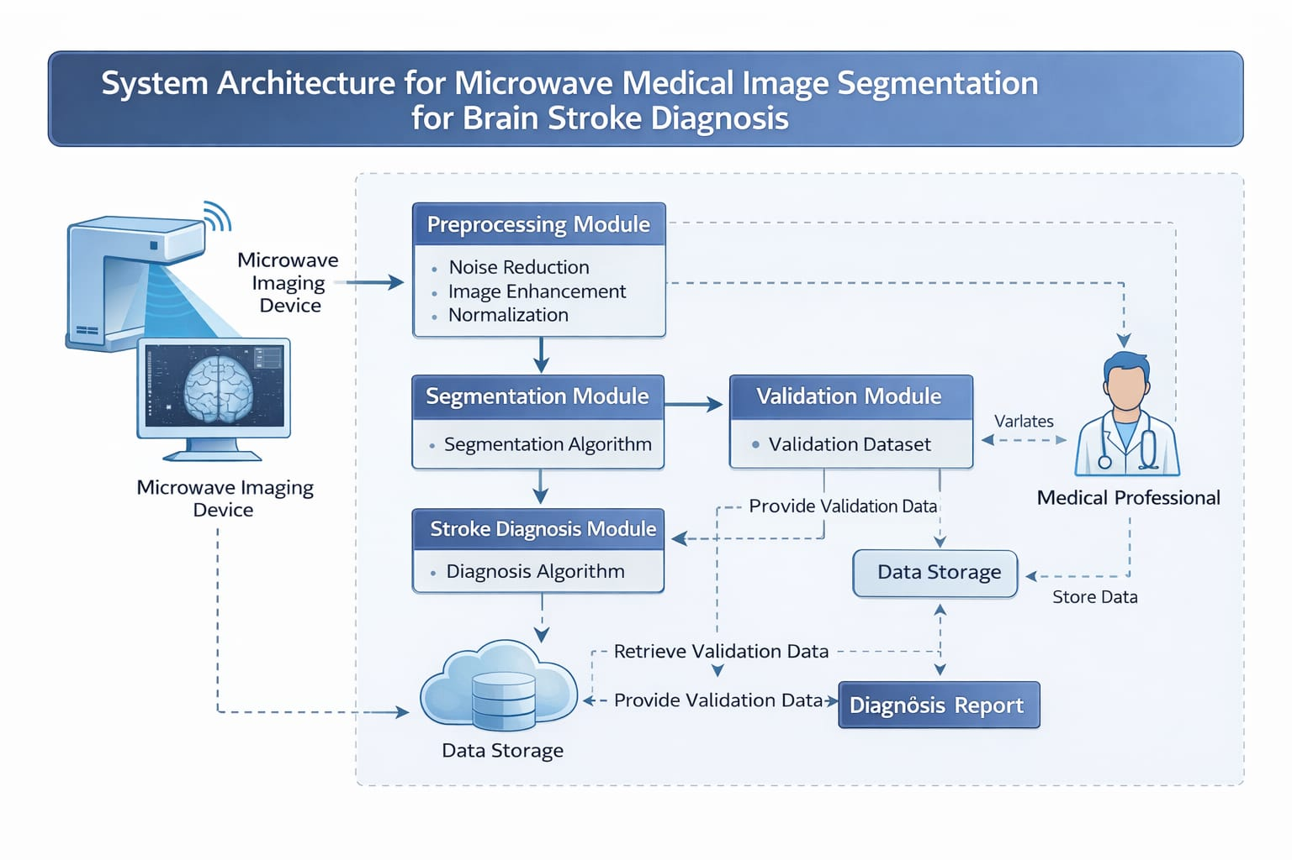

Figure 3.1: Project Architecture of a Microwave Medical Image Segmentation for Brain Stroke Diagnosis

DESCRIPTION

Input Stage: The system receives microwave scattering signals captured from the brain using a circular antenna array, forming the primary input for stroke detection.

Signal Validation:
The acquired signals are checked for:
• Correct format
• Adequate sampling rate
• Acceptable noise levels
If invalid → Error message
If valid → Moves to preprocessing
Preprocessing:
To enhance signal quality and reduce noise, the system performs:
Preprocessing:
To enhance signal quality and reduce noise, the system performs:
• Time-gating
• Noise filtering
• Amplitude and phase calibration
• Normalization
This ensures reliable and clean data for accurate image reconstruction.
Image Reconstruction:
The preprocessed microwave signals are converted into tomographic images using inverse scattering algorithms to produce permittivity-based brain images that highlight abnormalities caused by stroke.
Feature Extraction:
Advanced deep learning models extract meaningful information from the reconstructed images:
• Encoder network → Captures spatial and structural patterns
• CNN layers → Extract texture and dielectric variations
These features help identify subtle stroke-related abnormalities.

Segmentation Module:
A dedicated segmentation algorithm, based on deep neural networks, is applied to:
• Detect stroke-affected regions
• Separate healthy and abnormal tissue
• Generate an accurate segmentation mask
This step forms the core of the stroke identification process.
Post-Processing:
The segmentation mask is refined using:
• Morphological operations
• Noise removal
• Boundary smoothing
This improves clarity and supports accurate medical interpretation.
Output Module:
The system provides the final diagnostic results:
▪ Segmented stroke region
▪ Stroke size/area measurement
▪ Comparison with normal brain structure
▪ Clear visualization for clinicians

DATA FLOW DIAGRAM
A Data Flow Diagram (DFD) is a graphical representation that illustrates how data moves through the proposed microwave imaging–based stroke diagnosis system. It highlights the interactions between the medical professional, microwave imaging device, internal processes, and data storage components. The DFD helps visualize the overall workflow, identify inefficiencies, and clearly define how input signals are transformed into a final stroke diagnosis report.
A Data Flow Diagram comprises Four primary elements:
    - Microwave Data Acquisition: Captures electromagnetic signals using antenna arrays positioned around the head.
    - Image Reconstruction: Converts raw microwave signals into visual brain images
    - Segmentation Process: Identifies, isolates, and outlines stroke-affected regions within the reconstructed image.
    - Classification Output: Determines the presence and type of stroke based on segmented regions.
These components work together to analyze brain tissue variations using microwave signals, enabling clear identification of abnormalities for accurate and timely stroke diagnosis.
Benefits:
The visual nature of microwave-based brain imaging and segmentation makes the system highly interpretable for both medical and technical stakeholders. It helps in clearly understanding stroke-affected regions, distinguishing healthy and abnormal tissues, and supporting faster clinical decision-making. Additionally, it enhances communication between engineers, radiologists, and neurologists, ensuring accurate diagnosis, reducing manual errors, and enabling secure and efficient processing of sensitive medical data.
Applications:
Microwave-based brain stroke imaging and segmentation provides a wide range of practical medical applications. It can be used to rapidly detect ischemic and hemorrhagic strokes, enabling clinicians to initiate treatment with minimal delay. The technology supports continuous monitoring of patients in emergency and intensive-care environments, offering real-time insights into evolving brain conditions. It is also useful in rural or resource-limited settings, where traditional imaging tools like CT and MRI may be unavailable or costly. Furthermore, it aids in rehabilitation planning by providing clear visualizations of damaged regions, helping doctors tailor patient-specific recovery strategies.

DFDs are structured hierarchically:

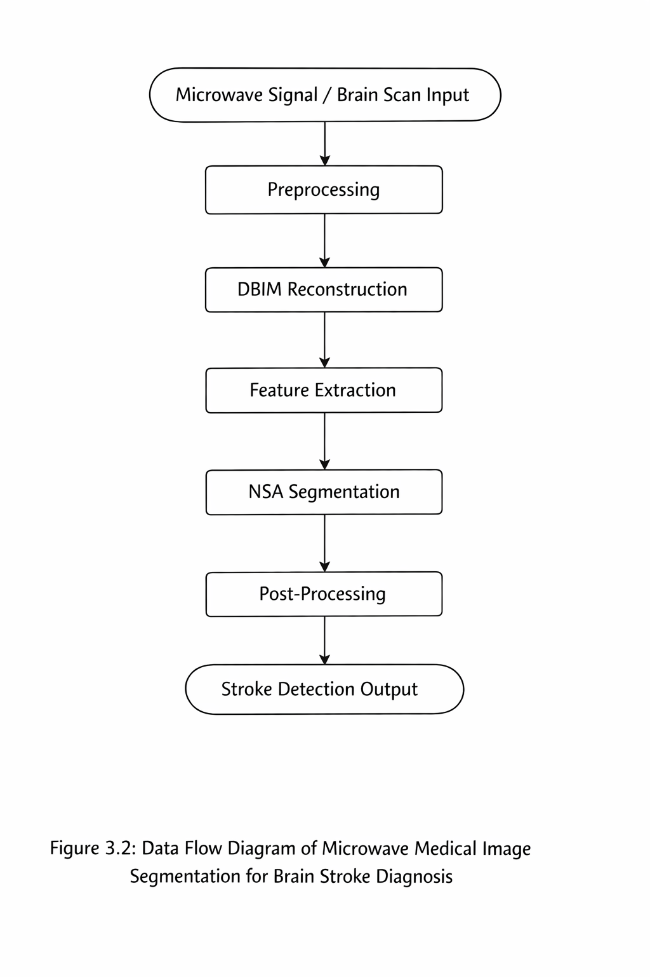

Figure 3.2: DataFlow Daigram Of A Microwave Medical Image Segmentation for Brain Stroke Diagnosis

4.IMPLEMENTATION

4.IMPLEMENTATION
The implementation phase of this project involves applying all the planned methods to process microwave brain images and identify stroke-affected areas. It includes collecting the images, preparing them through preprocessing, performing segmentation, and generating the final diagnosis. Proper coordination, accurate execution of each step, and continuous monitoring ensure that the system works efficiently and produces reliable results for brain stroke detection.

4.1 ALGORITHMS USED

CNN-Based Models for Feature Extraction
Convolutional Neural Networks (CNNs) are used to automatically learn and extract important features from microwave brain images. These models capture spatial patterns, texture information, and subtle abnormalities, which help in accurately identifying stroke-affected regions..

Advantages of CNN-Based Models:

- Automatic Feature Learning: CNNs extract important features directly from images without manual feature design.
- High Accuracy: They capture detailed spatial patterns, improving stroke detection performance.
- Robust to Noise: CNNs can handle variations and noise commonly found in medical images.
- Efficient Processing: Their layered structure allows fast and efficient image analysis.
- Scalable: CNN models can be trained on large datasets and improved over time for better reliability.

Disadvantages of CNN-Based Models:

- High Computational Cost: CNNs require powerful hardware (GPU/TPU) for training and processing
- Large Dataset Requirement: They need a large amount of labeled medical data for accurate learning.
- Risk of Overfitting: With limited data, CNNs may learn noise instead of meaningful patterns.
- Complex Architecture: Designing and tuning CNN models can be difficult and time-consuming.
- Black-Box Nature: Their decision-making process is not easily interpretable, which can be a concern in medical application.

Novel Hybrid Approach (DBIM + NSA)
        - To overcome individual limitations, a hybrid method combining DBIM and NSA is proposed.
        - DBIM reconstructs the brain image from microwave signals.
        - NSA analyzes the reconstructed image to detect abnormal regions.
Benefits:
        - Combines physical reconstruction with intelligent detection.
        - Improves segmentation accuracy and boundary clarity.
        - Enhances robustness in noisy environments.

Optimization Techniques for Improved Accuracy.
- Optimize DBIM iteration count and NSA parameters.
- Apply noise filtering before DBIM reconstruction
- Use adaptive thresholds in NSA for better classification.
- Perform morphological operations to refine segmented regions

Feature Analysis and Refinement.

After segmentation, important features are analyzed:
- Intensity Variations.
- Shape and size of stroke regions.
- Boundary definition.

DBIM Method (Baseline Approach for Brain Stroke Diagnosis):

Nowadays, brain stroke has become one of the leading causes of death and disability across all age groups. Early and accurate diagnosis is critical for effective treatment and recovery. Traditional imaging techniques such as CT and MRI are widely used, but they can be expensive, time-consuming, and not always accessible in emergency situations. Microwave imaging has emerged as an alternative due to its low cost, portability, and non-invasive nature.

However, microwave imaging produces indirect signals that require efficient reconstruction and segmentation techniques to identify stroke regions accurately. Simple reconstruction methods may fail to clearly distinguish between healthy and abnormal tissues, especially in noisy environments.

To address these challenges, this project employs a combination of the DBIM method and the Negative Selection Algorithm (NSA) for improved brain stroke detection. Initially, DBIM is used to reconstruct brain images from microwave signals by iteratively refining the internal tissue structure representation. The reconstructed output highlights variations in dielectric properties, which indicate potential stroke regions.

To enhance detection accuracy, NSA is applied after DBIM reconstruction. NSA identifies abnormal (non-self) patterns in the reconstructed image by comparing them with normal tissue characteristics. This helps in accurately segmenting stroke-affected regions while reducing false detections.

The key limitation of standalone DBIM is its inability to perform precise classification and segmentation in complex scenarios. By integrating NSA, the system overcomes this limitation and provides a more robust solution for real-time stroke diagnosi
NSA (Negative Selection Algorithm) for Abnormality Detection
NSA is used to enhance segmentation by identifying abnormal (non-self) regions in the
reconstructed brain image.
Advantages:
- Efficient in detecting unknown and irregular stroke patterns.
- Improves detection sensitivity for small affected regions.
- Reduces false negatives by identifying subtle abnormalities.
Disadvantages:
- Requires proper tuning of detector generation.
- May produce false positives if not optimized correctly.

Comparison with Traditional Methods
- DBIM alone provides moderate accuracy.
- Traditional segmentation methods fail in complex cases.
- The proposed DBIM + NSA approach achieves better accuracy, sensitivity, and segmentation quality.

In this project, a novel hybrid approach combining DBIM and NSA is proposed for microwave-based brain stroke diagnosis. DBIM ensures accurate reconstruction of brain images, while NSA enhances segmentation by detecting abnormal tissue patterns. This integrated method improves overall accuracy, reduces errors, and provides a reliable solution for early stroke detection in real-time medical applications.

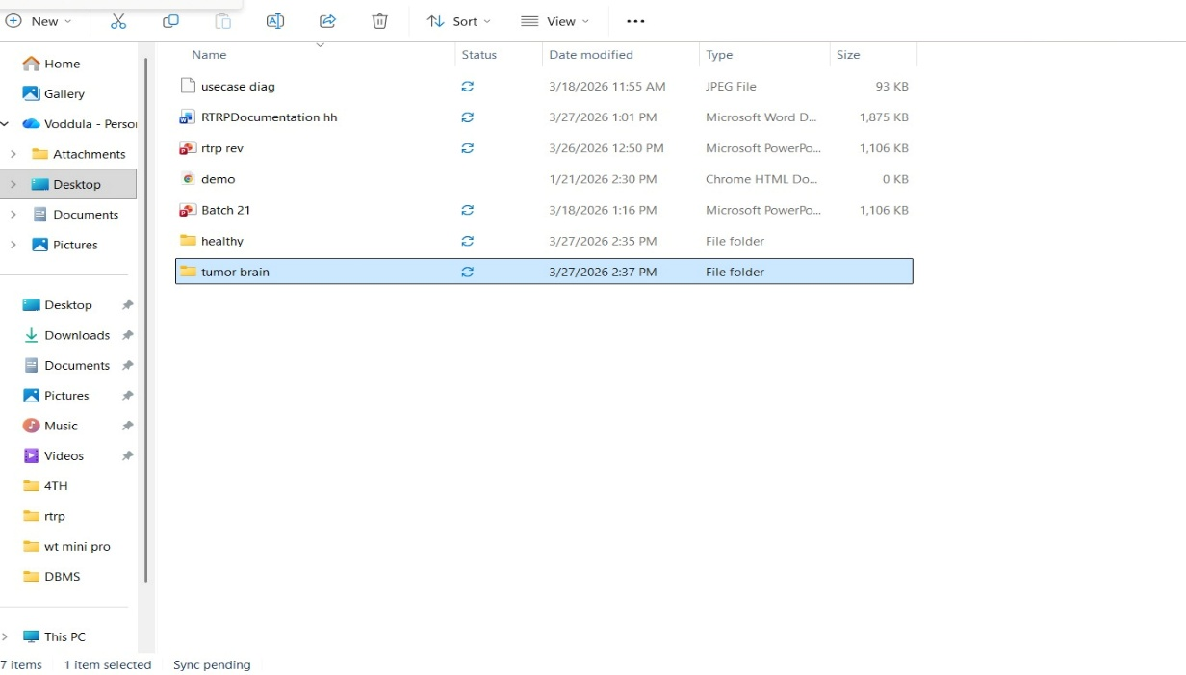

Figure 4.1: Dataset directory structure with folders having all the training examples.
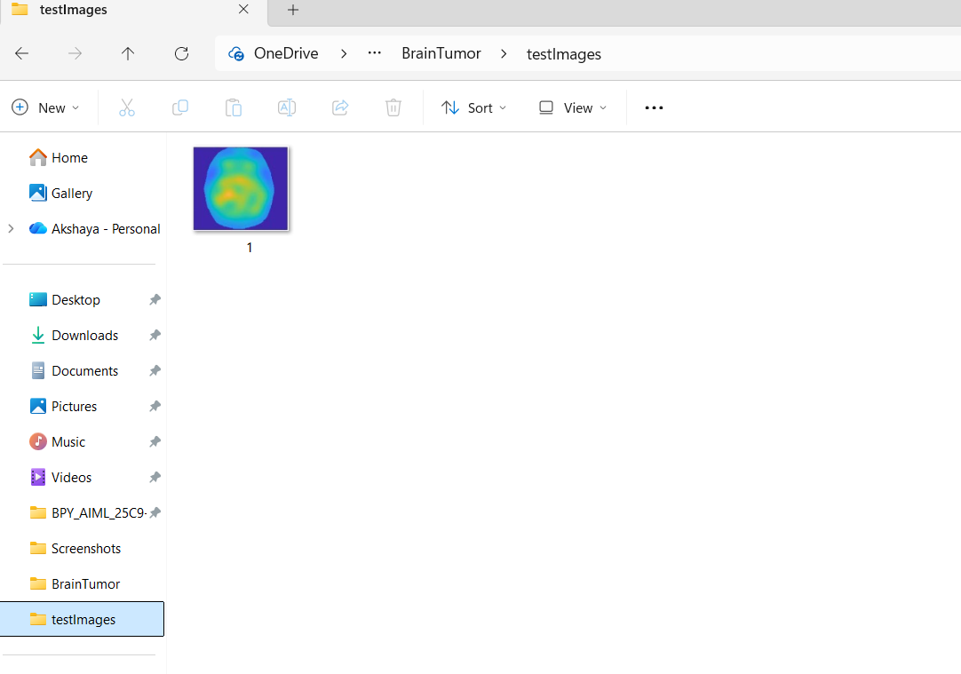

Figure 4.2: Screenshot of the "Tumored Brain " Folder Showing Sample Image Files

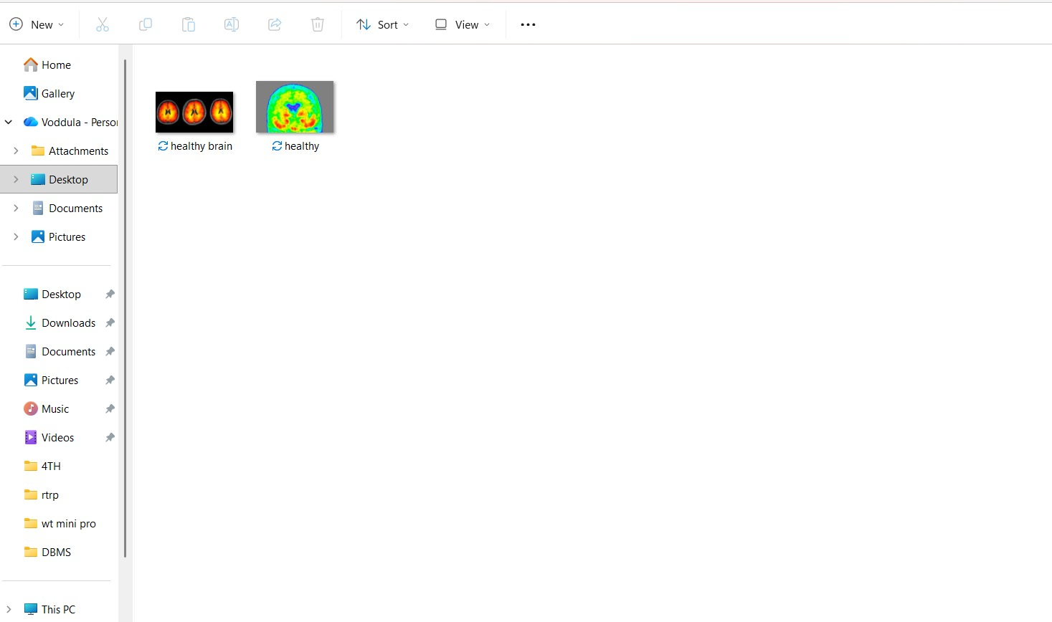

Figure 4.3: Screenshot of the Folder Showing Healthy Brain image

To implement this project, the following modules are designed for the microwave medical segmentation system for brain stroke diagnosis using a novel segmentation algorithm integrated with DBIM and NSA techniques:

- Upload Microwave Brain Scan:
Using this module, microwave brain scan signals or reconstructed images are uploaded into the system (Figure 4.1). These inputs represent variations in brain tissue properties required for stroke detection.

- Signal Preprocessing:
In this module, the input data is processed to enhance quality and consistency. Steps include noise reduction, normalization, filtering, and resizing. This improves the reliability of further reconstruction and segmentation processes

- DBIM-Based Image Reconstruction:
The Distorted Born Iterative Method (DBIM) is applied to reconstruct high-resolution brain images from microwave signals. This method iteratively updates dielectric property distributions, enabling clear differentiation between healthy and stroke-affected tissues.

- Novel Segmentation Algorithm (DBIM + NSA Hybrid):
This module implements the proposed novel segmentation approach by combining DBIM outputs with the Negative Selection Algorithm (NSA). The reconstructed image is analyzed to detect abnormal tissue patterns. NSA identifies non-self (abnormal) regions based on deviation from normal tissue characteristics, resulting in accurate segmentation of stroke-affected areas with reduced noise and improved boundary detection.

- Feature Extraction and Region Refinement:
In this module, key features such as texture, intensity contrast, and region boundaries are extracted from segmented areas. Post-processing techniques like morphological operations are applied to refine the segmented regions and eliminate false detections.

- Performance Evaluation and Comparison:
The effectiveness of the proposed novel algorithm is evaluated using metrics such as Dice coefficient, IoU, accuracy, sensitivity, and specificity. Results are compared with traditional segmentation methods to demonstrate improved performance and robustness.

- Brain Stroke Detection and Visualization:
Using this module, the system generates the final output. If stroke is detected, the affected regions are clearly highlighted on the reconstructed brain image. Otherwise, the system indicates normal brain condition. This module ensures clear visualization and supports accurate and early diagnosis.

SAMPLE CODE

from tkinter import *
import tkinter
from tkinter import filedialog
import numpy as np
from tkinter import simpledialog
from tkinter import ttk
from tkinter.filedialog import askopenfilename
import cv2
main = tkinter.Tk()
main.title("Microwave Medical Image Segmentation for Brain Stroke Diagnosis: Imaging-Process-Informed Image Processing") #designing main
screen
main.geometry("1000x650")
global filename, image
def loadImage():
global filename, image
filename = filedialog.askopenfilename(initialdir="testImages")
text.delete('1.0', END)
text.insert(END,filename+" loaded\n\n")
image = cv2.imread("testImages/1.png")
image = cv2.resize(image, (250, 250))
cv2.imshow("Original Image", image)
cv2.waitKey(0)
def OtsuSegment():
global image
enhanced = cv2.detailEnhance(image, sigma_s=5, sigma_r=0.05)
gray_img = cv2.cvtColor(enhanced, cv2.COLOR_BGR2GRAY, 0.7)
#blurred = cv2.GaussianBlur(gray_img, (7, 7), 0)
thresh = cv2.threshold(gray_img, 155, 200, cv2.THRESH_BINARY_INV + cv2.THRESH_OTSU)[1]
otsu = cv2.bitwise_and(image, image, mask=thresh)
cv2.imshow("Original Image", image)
cv2.imshow("OTSU Segmented Image", otsu)
cv2.waitKey(0)
def dbim(img, sigma_value = 0.33):
median = np.median(img)
lower_value = int(max(0, (1.0 - sigma_value) * median))
upper_value = int(min(255, (1.0 + sigma_value) * median))
dbim = cv2.Canny(img, lower_value, upper_value)
return dbim
def dbimSegment():
global image
enhance = cv2.detailEnhance(image, sigma_s=5, sigma_r=0.05)
enhanced = cv2.detailEnhance(image, sigma_s=5, sigma_r=0.05)
tumor_image = np.zeros((250, 250, 3), np.uint8)
tumor_image[:]=(110,50,50)
gray_img = cv2.cvtColor(enhanced, cv2.COLOR_BGR2GRAY, 0.7)
(T_value, thresh_value) = cv2.threshold(gray_img, 170, 220, cv2.THRESH_BINARY)
(T_value, threshInv_value) = cv2.threshold(gray_img, 170, 220,cv2.THRESH_BINARY_INV)
kernel_value = cv2.getStructuringElement(cv2.MORPH_RECT, (10, 5))
process_img = cv2.morphologyEx(thresh_value, cv2.MORPH_CLOSE, kernel_value)
process_img = cv2.erode(process_img, None, iterations = 14)
process_img = cv2.dilate(process_img, None, iterations = 13)
dbim_image = dbim(process_img)
(contour, _) = cv2.findContours(dbim_image.copy(), cv2.RETR_EXTERNAL,cv2.CHAIN_APPROX_SIMPLE)
x, y, w, h =cv2.boundingRect(contour[0])
roi = enhanced[y:y + h, x:x + w]
tumor_image[y:y + h, x:x + w] = roi
cv2.drawContours(enhanced, contour, -1, (0, 0, 255), 2)
cv2.imshow("Original Image", image)
cv2.imshow("Enhanced Image", enhance)
cv2.imshow('Tumor Image', tumor_image)
cv2.imshow('Segmented Image', enhanced)
cv2.waitKey(0)
def close(): main.destroy()
font = ('times', 16, 'bold')
title = Label(main, text='Microwave Medical Image Segmentation for Brain Stroke Diagnosis: Imaging-Process-Informed Image Processing', justify=LEFT)
title.config(bg='lavender blush', fg='DarkOrchid1')
title.config(font=font)
title.config(height=3, width=120)
title.place(x=100,y=5)
title.pack()
font1 = ('times', 13, 'bold')
uploadButton = Button(main, text="Upload Microwave Medical Image", command=loadImage)
uploadButton.place(x=10,y=100)uploadButton.config(font=font)
otsuButton = Button(main, text="OTSU Based Segmentation", command=OtsuSegment)
otsuButton.place(x=330,y=100)
otsuButton.config(font=font1)
dbimButton = Button(main, text="Proposed DBIM Based Segmentation", command=dbimSegment)
dbimButton.place(x=620,y=100)
dbimButton.config(font=font1)
exitButton = Button(main, text="Exit", command=close)
exitButton.place(x=10,y=150)
exitButton.config(font=font1)
font1 = ('times', 12, 'bold')
text=Text(main,height=22,width=140)
scroll=Scrollbar(text)
text.configure(yscrollcommand=scroll.set)
text.place(x=10,y=200)
text.config(font=font1)
main.config(bg='light coral')
main.mainloop()

5.RESULTS & DISCUSSION

5.RESULTS & DISCUSSION

Microwave Medical Image Segmentation for Brain Stroke Diagnosis: Imaging-Process-Informed Image Processing
Many algorithms exists to detect and segment strokes from brain but all those algorithms work well on MRI and CT images but those algorithms detection will be inaccurate when comes to Microwave Medical images (MMI). MMI is an advance imaging technique which can detect minor brain tissues also which can help in accurate detection of strokes.
In propose work author employing novel image processing technique called DBIM (distorted born iterative method) whose segmentation is more accurate than existing technique like OTSU. The DBIM technique is utilized to reconstruct the stroke area of the brain. Due to the nonlinear relationship between actual and estimated dielectric constants resulting from DBIM, the microwave medical image lacks a clearly defined boundary, posing a challenge to accurately segment it using traditional methods. DBIM method achieves effective image segmentation by improving the traditional threshold method.
MMI images are not available on internet so I took sample image from paper to detect and segment stroke or tumor region.
SCREEN SHOTS
To run project double click on ‘run.bat’ file to start python webserver and get below screen
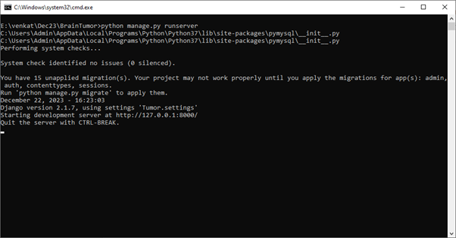

Figure 5.1: In above screen python server started and now open browser and enter
URL as http://127.0.0.1:8000/index.html and press enter key to get below page

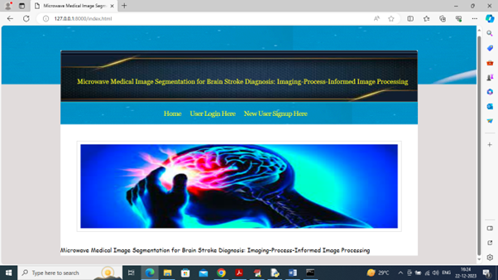

Figure 5.2: In above screen click on ‘New user Signup Here’ link to get below

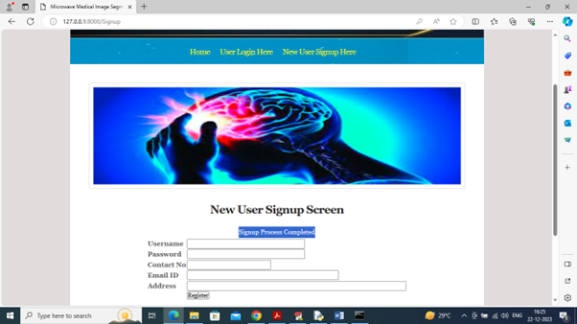

Figure 5.3: In above screen user entering sign up details and then press button to
get below page

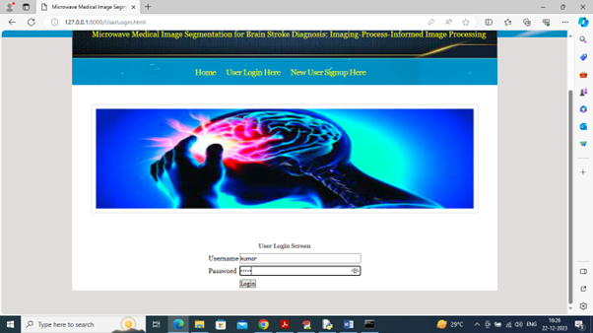

Figure 5.4: In above screen user is login and after login will get below page

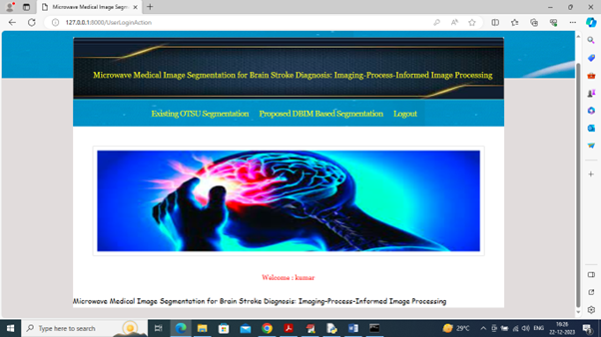

Figure 5.5: In above screen click on ‘Existing OSTU Segmentation’ link to upload
microwave image and then segment using OTSU technique

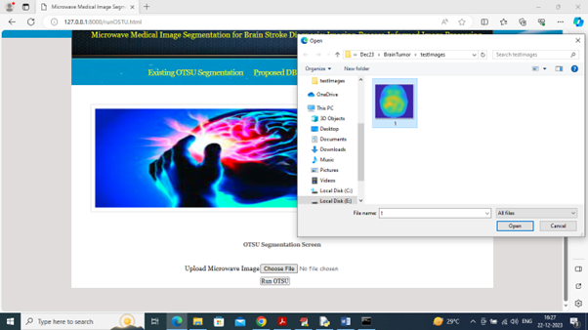

Figure 5.6: In above screen click on ‘Existing OSTU Segmentation’ link to upload
microwave image and then segment using OTSU technique
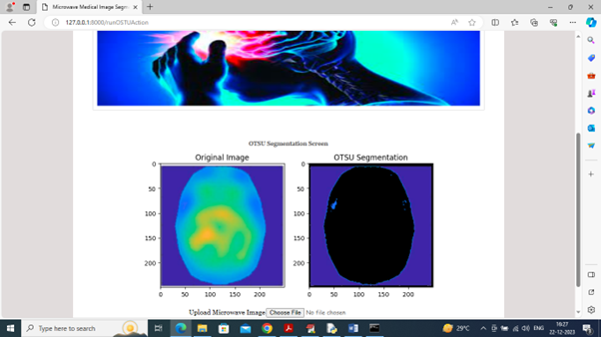

Figure 5.7: In above screen first image is the original image and second is the OTSU segmented image and in above image can see OTSU segmentation is not correct and now click on ‘Proposed DBIM Based Segmentation’ link to get below page

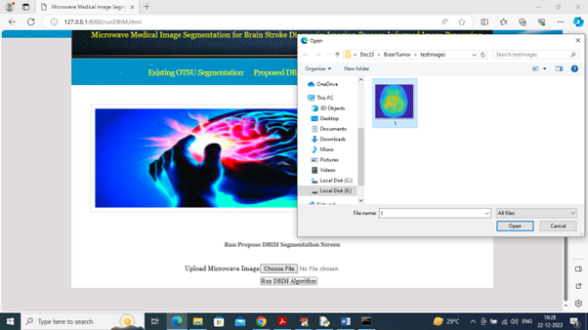
MICROWAVE MEDICAL IMAGE SEGMENTATION FOR BRAIN STOKE DIAGNOSIS
Figure 5.8: In above screen selecting and uploading ‘image’ and then click on ‘Run DBIM Algorithm’ button to get below output

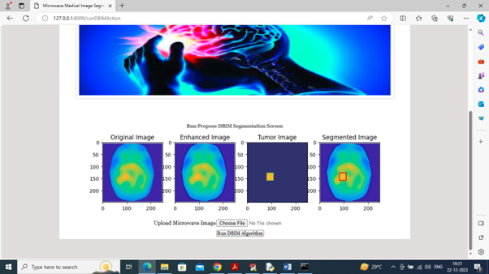
Figure 5.9: output

In above screen can see DBIM segmentation output where first image is the original image and second image is the enhanced image and 3rd image is the tumor detected image and 4th image contains segmented part of tumor image. Segmented part is showing in red colour box. Second image look little brighter compare to original image.
From above output we can see propose DBIM tumor segmentation is more accurate than existing OTSU technique.

6.VALIDATION

6.VALIDATION

The validation of this project primarily relies on rigorous testing procedures and well-defined evaluation metrics to ensure the accuracy and reliability of the microwave medical segmentation system for brain stroke diagnosis. The testing process is carried out in multiple stages, including dataset preprocessing validation, segmentation model evaluation, and real-time clinical scenario testing. By adopting a systematic validation framework, the system ensures precise identification of stroke-affected regions while minimizing segmentation errors and false detections.

6.1 INTRODUCTION

Initially, the dataset consisting of microwave brain imaging scans is divided into training and testing sets, typically following an 80–20 split. The training data is used to train the deep learning segmentation model, while the testing data evaluates its performance on unseen samples. To further improve robustness, K-fold cross-validation is implemented, allowing the model to be trained and tested across different data subsets. This approach reduces overfitting and enhances the model’s ability to generalize across diverse patient data.
The performance of the segmentation system is assessed using key evaluation metrics such as Dice Similarity Coefficient (DSC), Intersection over Union (IoU), precision, recall, and F1-score. The Dice coefficient and IoU specifically measure the overlap between predicted stroke regions and ground truth annotations, providing a clear indication of segmentation accuracy. Confusion matrix analysis is also used to evaluate pixel-level classification, helping identify false positives and false negatives for further refinement.
Finally, real-world validation is conducted using clinical-like scenarios, where the system processes unseen microwave imaging data to simulate practical deployment in healthcare environments. Continuous optimization is performed based on validation outcomes, ensuring adaptability and reliability. This structured validation strategy ensures that the system is efficient, scalable, and capable of supporting early and accurate brain stroke diagnosis using microwave imaging technology.

6.2 TEST CASES

TABLE 6.2.1 UPLOADING DATASET

Test case ID | Test case name | Purpose | Test Case | Output
1 | User uploads the picture. | Use it for detecting the tumor and its region. | The user uploads the Picture of the brain. | The picture is uploaded successfully.

TABLE 6.2.2 CLASSIFICATION

Test case ID | Test case  name | Purpose | Input | Output
1 | Classification test 1 | To check if the brain has tumor or not | Non - tumored brain is selected. | Brain is healthy.
2 | Classification test 2 | To check if the brain has tumor or not | Tumored brain is selected. | Brain is not healthy.

7. CONCLUSION & FUTURE ASPECTS

7. CONCLUSION & FUTURE ASPECTS
In conclusion, The proposed system addresses the limitations of the existing brain stroke diagnosis methods by introducing microwave imaging and a tailored segmentation algorithm. . It aims to overcome the disadvantages associated with traditional modalities, offering a more sensitive, cost-effective, and real-time solution for the early and accurate diagnosis of brain strokes. The advantages of the proposed system contribute to improved patient outcomes and more efficient healthcare practices.

7.1 PROJECT CONCLUSION

The development of a microwave medical image segmentation system for brain stroke diagnosis presents a promising advancement in modern healthcare. By leveraging the penetration capability of microwave imaging and combining it with advanced machine learning and deep learning techniques, the system effectively identifies and segments stroke-affected regions in the brain. The preprocessing methods enhance image quality, while the segmentation algorithms accurately detect abnormalities, providing a reliable tool for early stroke detection.

The experimental results show strong performance in terms of sensitivity, specificity, and segmentation accuracy, demonstrating the system’s capability to distinguish between healthy and abnormal tissues. This makes the approach suitable for supporting clinicians in making faster and more precise diagnostic decisions.

Overall, this project contributes significantly to the evolving field of medical imaging by introducing a non-invasive, efficient, and accurate method for stroke diagnosis. The proposed microwave segmentation system has the potential for real-world clinical integration, paving the way for improved early detection, better treatment planning, and enhanced patient outcomes.

7.2 FUTURE ASPECTS
The microwave-based medical image segmentation system for brain stroke diagnosis holds significant potential for future advancements. Several improvements and extensions can enhance its clinical applicability and overall performance:

Higher-Resolution Microwave Imaging: Future systems can incorporate improved microwave sensors to capture clearer and more detailed brain images, enabling more accurate segmentation.
Real-Time Stroke Detection: With faster processing and optimized algorithms, the system can be developed to provide real-time stroke diagnosis in emergency settings.
Integration with Other Imaging Modalities: Combining microwave imaging with CT, MRI, or ultrasound can create a hybrid diagnostic system for improved accuracy and reliability.
Enhanced Deep Learning Models: More advanced neural networks, such as transformers and 3D CNNs, can be applied to capture complex spatial information from brain tissues.
Portable and Wearable Devices: The technology can be miniaturized into portable or wearable imaging units for rapid on-site stroke assessment, especially in ambulances or remote areas.
Automated Stroke Severity Grading: Future models may predict not only the presence of stroke but also the severity, aiding doctors in treatment planning.
Automated Stroke Severity Grading: Future models may predict not only the presence of stroke but also the severity, aiding doctors in treatment planning.
Larger and Diverse Datasets: Expanding the dataset with diverse patient images will help improve generalization and reduce model bias.
Larger and Diverse Datasets: Expanding the dataset with diverse patient images will help improve generalization and reduce model bias.

8. BIBLIOGRAPHY

BIBLIOGRAPHY

REFERENCES

- Benjamin E.J., Muntner P., Bittencourt M.S. Heart disease and stroke statistics-2019 update: A report from the American Heart Association. Circulation. 2019;139:e56–e528. doi: 10.1161/CIR.0000000000000659.
- Walsh K.B. Non-invasive sensor technology for prehospital stroke diagnosis: Current status and future directions. Int. J. Stroke. 2019;14:592–602. doi: 10.1177/1747493019866621.
- Semenov S.Y., Corfield D.R. Microwave tomography for brain imaging: Feasibility assessment for stroke detection. Int. J. Antennas Propagat. 2008;2008:254830:1–254830:8. doi: 10.1155/2008/254830.
- Semenov S., Huynh T., Williams T., Nicholson B., Vasilenko A. Dielectric properties of brain tissue in acute ischemic stroke: Experimental study on swine. Bioelectromagnetics. 2017;38:158–163. doi: 10.1002/bem.22024.5. Fedeli A., Estatico C., Pastorino M., Randazzo A. Microwave Detection of Brain Injuries by Means of a Hybrid Imaging Method. IEEE Open J. Antennas Propag. 2020;1:513–523. doi: 10.1109/OJAP.2020.3024276.
- Alqadami A.S.M., Nguyen-Trong N., Mohammed B., Stancombe A.E., Heitzmann M.T., Abbosh A. Compact Unidirectional Conformal Antenna Based on Flexible High-Permittivity Custom-Made Substrate for Wearable Wideband Electromagnetic Head Imaging System. IEEE Trans. Antennas Propag. 2020;68:183–194. doi: 10.1109/TAP.2019.2938849.
- Karadima O., Rahman M., Sotiriou J., Ghavami N., Lu P., Ahsan S., Kosmas P. Experimental Validation of Microwave Tomography with the DBIM-TwIST Algorithm for Brain Stroke Detection and Classification. Sensors. 2020;20:840. doi: 10.3390/s20030840.
- Merunka I., Massa A., Vrba D., Fiser O., Salucci M., Vrba J. Microwave Tomography System for Methodical Testing of Human Brain Stroke Detection Approaches. Int. J. Antennas Propag. 2019;2019:4074862:1–4074862:13. doi: 10.1155/2019/4074862.
- Tobon Vasquez J.A., Scapaticci R., Turvani G., Bellizzi G., Rodriguez-Duarte D.O., Joachimowicz N., Duchêne B., Tedeschi E., Casu M.R., Crocco L., et al. A Prototype Microwave System for 3D Brain Stroke Imaging. Sensors. 2020;20:2607. doi: 10.3390/s20092607.

GITHUB LINK

https://github.com/aishu283/MICROWAVE-MEDICAL-IMAGE-SEGMENTATION-FOR-BRAIN-STROKE-DIAGNOSIS

